Comparison of London Boroughs for student housing

1. Introduction

1.1 Background
Finding Neighborhoods that have facilities that students would like to have. Let's say I am a property developer for student accommodation. I am interested in finding neighbourhoods that are near universities and located near the facilities that students would desire (gyms, convenience shops, nightclubs) whilst being affordable. So I will analyse areas surrounding universities, to find areas that would provide me with maximal profit whilst keeping being appealing to students in the area.

1.2 Business perspective
While the income yield is a crucial measure of investment properties, the focus of this analysis will be on finding neighbourhoods with appealing amenities. There is a saying that is often preached within real estate agencies: 'location, location, location,' and in this report, the aims will be to find the right location, as that is all that matters.

1.3 Student perspective
King's College which is in London will be the university investigated. London is known to have some of the highest rents in the world, so obtaining affordable yet characteristic accommodation for students is a difficult problem that could result in large financial gains as the ordinary student rent range between £135 - £210 per week [1].
With the soaring cost of living in London, It is no surprise that 44% of students struggle to pay their rent each month [2] and 31 % finding their studies affected. Combined with increasing tuition fees, the crippling student debt crisis is a real problem in London and the rest of the UK. How can this keep going on? Now while attempts are being made to control rents through legislation [3]. However, this option is lengthy and unlikely to be successful, largely due to political opposition. So, it is our responsibility to seek more desirable housing to reduce students cost, to help the next generation with the continual goal of learning and improving themselves. As it is today's student that will become tomorrows inventors, business owners and professors.

2. Method

2.1 Problem
We do not have the perfect conditions for students to find affordable places to live in, but we do have access to vast amounts of data relating to the location of venues in London (using the Foursquare API), the average rental prices in each area (using data from Spare room) and average house prices (using HM land registry).

2.2 Aim
From the data, we can extract the ideal areas that students would live to live in, by looking at the number of and types of venues in each area. To determine the optimal location, we must first find areas that are within a 45-minute commute of the university (King's College London) and have many of the following venues gym, coffee shop, nightclub, convenience shop, local to the area. Finding budget areas where these amenities exist could prove to be valuable for students finding affordable accommodation and investors finding attractive properties.

2.3 Data preparation
To start with a Wikipedia table [4] was used to create a data frame with each London’s boroughs coordinates, area. The table was imported using Python’s get request and imported directly to a Pandas DataFrame using the read_html function.
After creating the table into a Pandas DataFrame, the coordinates was converted from Degrees, minutes, and seconds to Decimal degrees, which will be useful for the APIs used later on in this report.
To finish off the data preparation, the locations of each borough was mapped using Folium to validate the coordinates given by Wikipedia.

2.4 Google's Distance Matrix API
In this report Google’s Distance Matrix API was used to calculate the commuting times from each borough to King’s College London (51.5146458, -0.118014653020563), for the arrival time of 9:00:00 am on April 11, 2019, by car. This time was chosen to provide represent a typical commute into university for a typical student and a car commute was chosen as the public transport route could not be calculated for each borough, whereas the car commute could be calculated for each borough.
The Distance Matrix was called using Python’s get request and results were extracted using Pandas. Only boroughs with a commute less than 45 minutes were chosen as longer commutes are unlikely to be tolerated by students.

2.5 Foursquare’s Explore API
For all the acceptable borough, found from the previous section, the venues surrounding each borough were found using Foursquare’s Explore API. The API was called using Python’s get request using the Coordinates found in section 2.3 and a radius was set to 500 m and 1000 venues. The type of venue (park, grocery store, gym…) was recorded and used.
The number of each type of venues was counted for each borough, then an average for each type of venue was calculated. Next, the order of most common venues was determined, such that for each borough the first, second, third… most common venues was known.

2.6 Clustering
To find ideal locations for students, areas will be clustered by venue and clusters will be compared to find the ones with the most ideal properties. Clusters with the most ideal areas will be extracted and rental prices will be compared to identify the areas where accommodation is affordable for students. Clustering will be carried out using Sklearn’s KMeans algorithm and all data will be in Pandas DataFrames.

2.7 Rental prices
Though out most of this project the focus has been on finding accommodation that is relevant to students through Foursquare’s data. However, student also care for the cost of accommodation (see section 1.1). So, rental price data will be taken from here such that the cost of accommodation can be compared between the ideal boroughs found in section 2.6. Then a table will be generated sorting out the borough from least expensive mean rental price to most expensive, rental prices will be for a single room by the month.

3. Results

3.1 Data preparation
Using the method detailed in section 2.3. Figure 1 was created to display the location of each London borough. All data was taken from Wikipedia table [4]. This map was created to validate the location data of the boroughs.
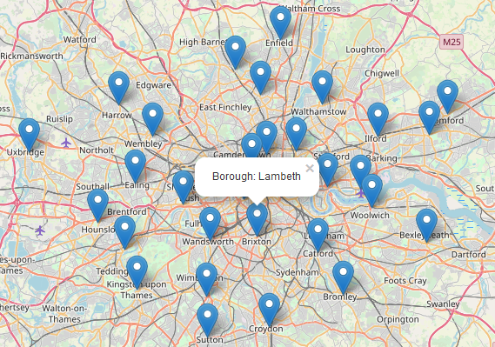Figure 1: Showing to location of each London borough.

3.2 Google's Distance Matrix API
The commuting time was calculated between each London borough and King’s College London, Strand campus. This was done using Google’s Distance matrix API, more details can be found in section 2.4. Figure 2 show the borough with a commuting time less than 45 minutes.
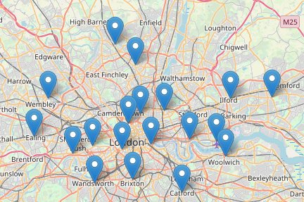Figure 2: Showing the boroughs within 45 minutes commute of King's College London.

3.3 Foursquare’s Explore API and Clustering
Using Foursquare’s Explore API, the venues local to each borough was found. These venues include shops, cafes, gyms and bars. With all venues found and inputted into a Pandas DataFrame. The boroughs were clustered using a Sklearn’s Kmeans algorithm, based on the most common venues to each borough. More details are given in section 2.4 and 2.5.
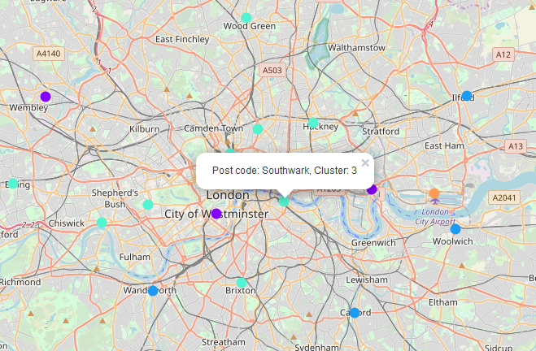Figure 3: Showing the acceptable London boroughs from fig 2 and their cluster, indicated by the color. Cluster 1 – Pruple, Teal - cluster 3

3.4 Rental prices
The cost of rent for the different boroughs can be found in table 1 and figure 4. The cheapest borough with the amenities that students would find useful are: Lambeth, Haringey and Southwark.

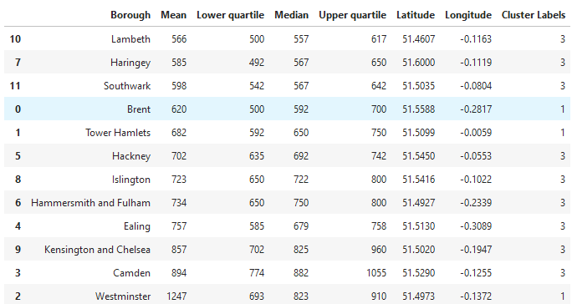Table 1: Showing the ideal boroughs found in fig 3 and the cost of renting a single bedroom in each of these boroughs, sorted by the mean price. Prices are by the month. Data taken from gov.uk.
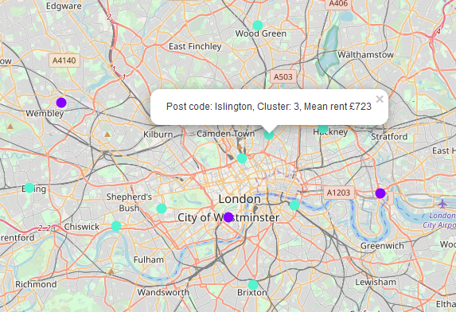Figure 4: Showing the data from fig 4 in a map made by Folium, where the color represents the cluster number and rental prices are in the labels of the markers.
Discussion

From this analysis we have found the following boroughs to be ideal for students living in London: Lambeth, Haringey and Southwark as the represented great value for money (see table 1) whilst also being located near venues such as gyms, parks, shops, etc. These boroughs could be used as a guide to find affordable housing for students.
Conclusion
As a whole, this project has been a success in finding affordable areas that would be suited to students. Especially in finding areas that are less well known, such as Lambeth. This information could be used by students or housing organisations to find areas to rent in or to develop student accommodation.
Future work could attempt to include the other costs of housing, such as commuting cost, for example the cost of train travel cards or car parking for each borough in Table 1, to build a more accurate picture of the cost of living in each borough. This would be essential to finding affordable accommodation.
In conclusion, the data analysis proved to be successful in find a number of areas that could be used or developed for student housing.

